

**Biology 2 Test: Geological Time and Evolution**

**SECTION 1: MULTIPLE CHOICE** (1 mark each)

Circle your answer in the section below:

1. Which of these is an example of an indirect fossil?

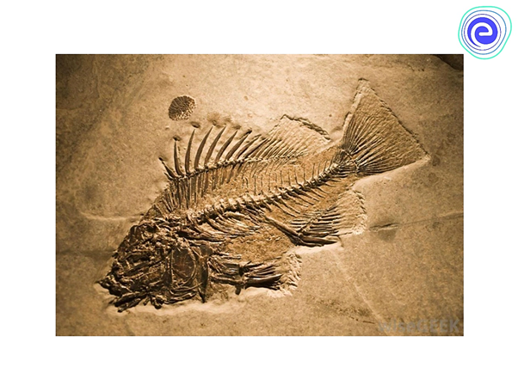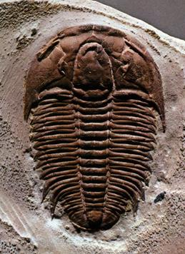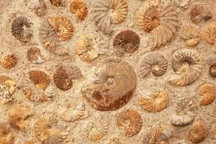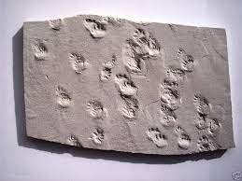

1. (b) (c) (d)

**The next two questions refer to the following diagram**

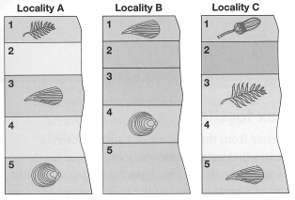

1. Which species could be considered an index fossil?

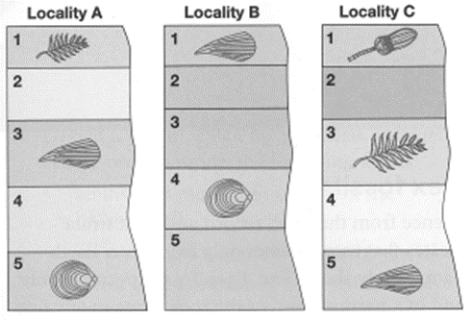

(a) (b) (c) (d)

1. Which sample contains the oldest rock strata?
   1. Locality A
   2. Locality B
   3. Locality C
   4. Impossible to determine from this information
2. The big dying was a global mass extinction event at the end of the Mesozoic era, with no more dinosaur fossils being located from subsequent fossil records.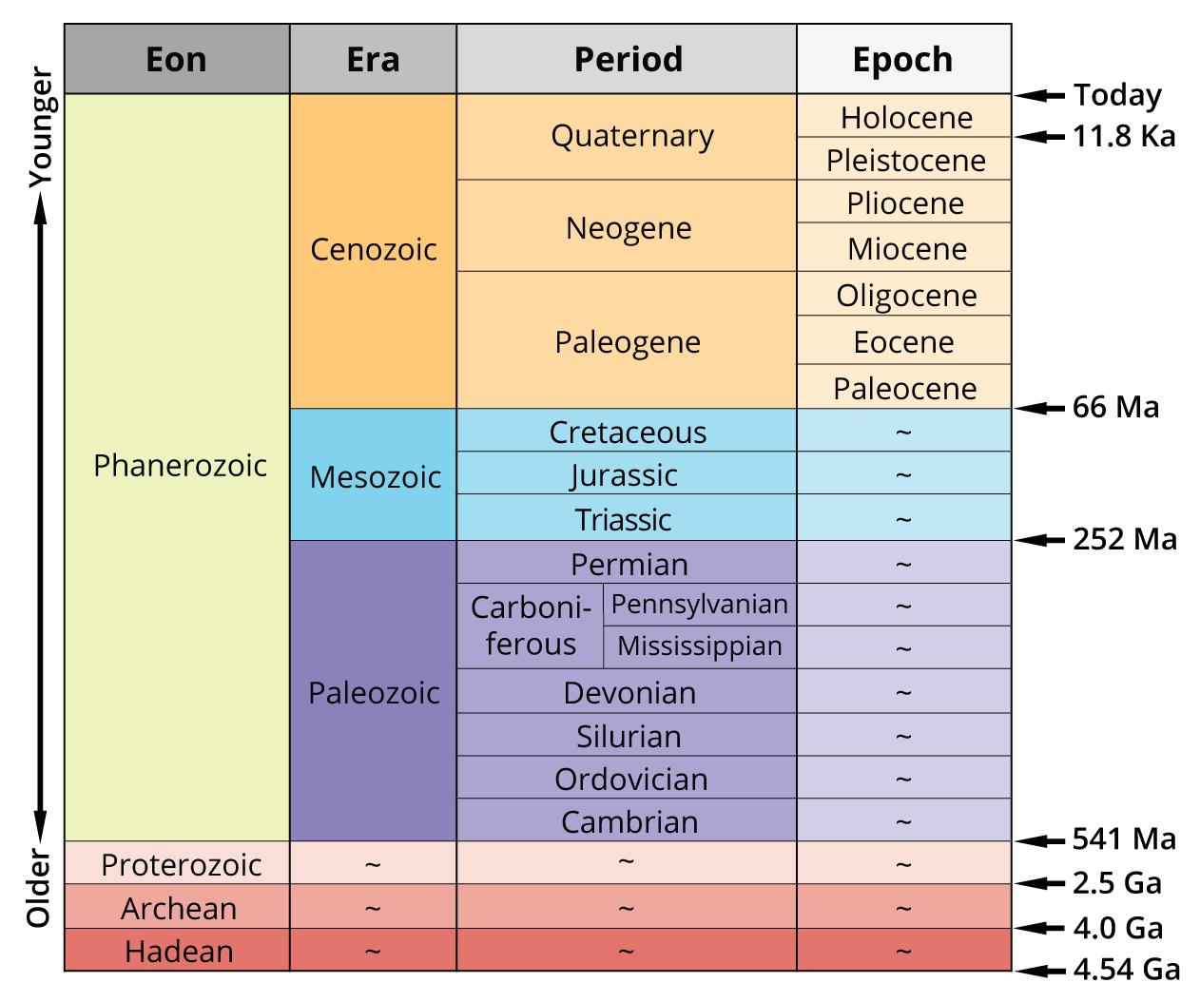

Which statement is correct?

* 1. The Cretaceous was the first period of the Mesozoic Era.
  2. Dinosaurs were alive from 252 to 66 million years ago.
  3. Dinosaurs were killed by the Cambrian Explosion.
  4. Eons, Eras and Periods are divided into equal lengths of time.

1. Which of the following is not an example of natural selection?
   1. Cheetahs have evolved to be faster as their prey has become faster.
   2. Giraffes have evolved longer necks to reach more food.
   3. Sheep are being bred to have finer wool.
   4. In nature, albino animals are rare as they are easier for predators to catch.
2. Carbon dating uses the radioisotope Carbon-14, which has a half life of 5700 years. A frozen mammoth found under the permafrost in Siberia was found to have 12.5 % or 1/8th the amount of Carbon-14 as a living organism. Estimate how long ago the mammoth died.
   1. 5700 years ago
   2. 11400 years ago
   3. 22800 years ago
   4. 45600 years ago
3. All things being different between and within species is called
   1. similarity
   2. speciation
   3. evolution
   4. diversity
4. Which is not an aspect of biodiversity?
   1. species diversity
   2. genetic diversity
   3. ecosystem diversity
   4. hybrid diversity
5. Darwin’s finches showed such changes that they were no longer the same species. Which is the best definition of a species?
   1. a group of individuals that are similar to each other
   2. a group of individuals that are able to interbreed to produce fertile offspring
   3. a group of individuals that live in isolation from other similar species
   4. a group of individuals that show the least variation
6. Natural selection only occurs when
   1. there is sexual reproduction.
   2. there are more offspring produced than will survive to breed.
   3. there is change in the environment.
   4. humans influence the environment.
7. Darwin’s Theory of Evolution says that
   1. living things change gradually over generations as they adapt to their changing environment.
   2. living things change suddenly in response to sudden changes in their environment.
   3. living things change themselves when they see the need to.
   4. living things change because of mutations.
8. Which of the following is not necessary for evolution?
   1. variation
   2. competition
   3. natural selection
   4. meiosis
9. Which of the following evidence for evolution would not be used to determine how closely related two species are?
   1. features which are not similar in structure but perform the same function in unrelated species, eg insect wings and bat wings
   2. similar structures which perform different functions in related species, eg dual bone in forearm of human, frog and pigeon
   3. structures which are found in related species, but which may no longer serve a function, eg whale pelvis
   4. fossils which show gradual change in similar species
10. Which of the following statements about Natural Selection is true?
    1. Natural Selection is based on the idea that life is an ongoing struggle for survival.
    2. Organisms do not need to compete for food, water, mates, light or space.
    3. Organisms compete for natural resources only with other members of the same species.
    4. Those individuals who compete successfully have less chance of passing on their genes.
11. Use the phylogenetic tree below to determine which species are most closely related?
    1. Human and mouse
    2. Platypus and Tammar wallaby
    3. Zebra finch and lizard
    4. Pufferfish and Elephant shark

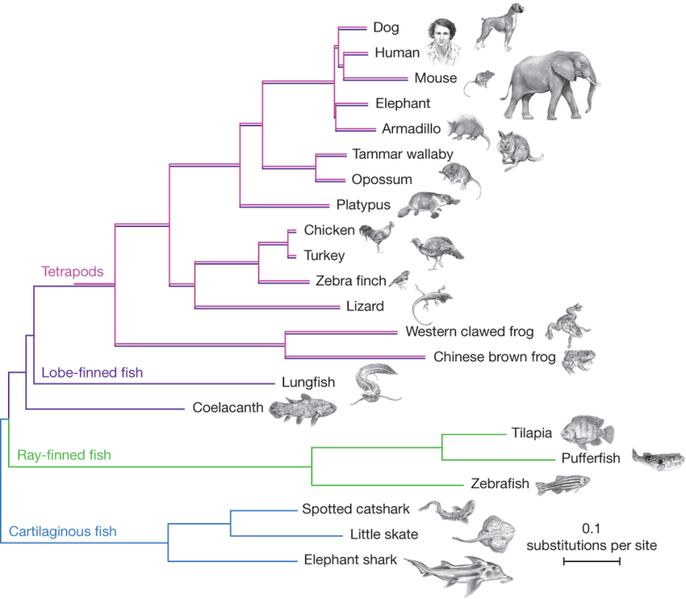

**SECTION 2: WRITTEN**

**Write your answers in the spaces provided.**

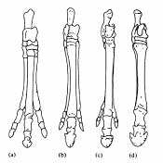

1. It is thought that modern horses with hooves evolved from ancient horses with three toes.
   1. What type of evidence for evolution does this assumption rely on? (2 marks)

_______________________________________________

_______________________________________________

* 1. List or briefly describe the **processes** that would have resulted in this change over time. (3marks)

_________________________________________________________________________

__________________________________________________________________________

__________________________________________________________________________

1. Scorpionflies (Mecoptera) and true flies (Diptera) have enough similarities that entomologists (scientists who study insects) consider them to be closely related. Scorpionflies have four wings of about the same size, and true flies have a large front pair of wings but the back pair is replaced by small club-shaped structures.

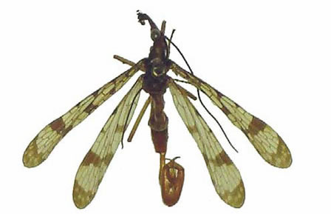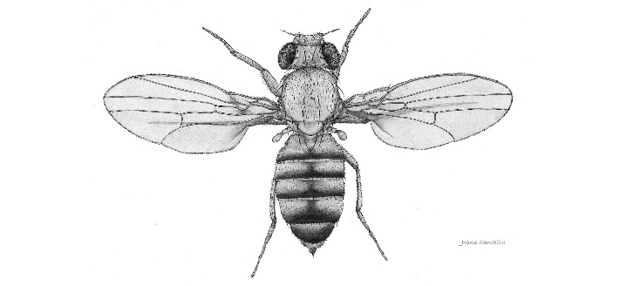

*Mecoptera Diptera*

* 1. Name this type of evidence for evolution. (1 mark)

______________________________________________________________

* 1. Briefly describe one other way that scientists could support their idea that these species have evolved from common ancestors? (2 marks)

________________________________________________________________

________________________________________________________________

________________________________________________________________

________________________________________________________________

________________________________________________________________

1. 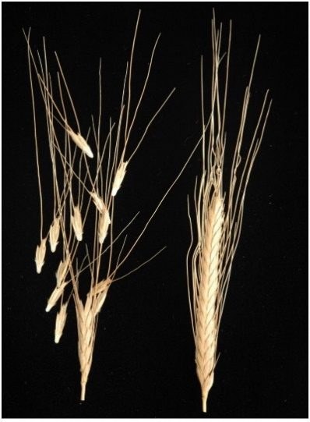Wild and ancient wheat varieties have shattering stalks that cause the grain to break off from the stalks while still green. Domesticated modern wheat varieties have non-shattering stalks that hold the grain together, even after the grain has ripened and dried. This allows the grain to be more easily harvested, as it does not fall to the ground.
   1. Is this an example of natural or artificial selection? (1 mark)

_______________________________________________

* 1. Where did this non-shattering gene come from? (1 mark)

_______________________________________________

* 1. What do you think would happen to the wild wheat population if domestic wheat was released into the wild?

_________________________________________________________________

_________________________________________________________________

_________________________________________________________________

(1 marks)

1. Explain how embryology is used to support the theory of evolution. Diagrams and examples may be useful.

______________________________________________________________________

______________________________________________________________________

______________________________________________________________________

______________________________________________________________________

(4 marks)

**END OF TEST (OUT OF 30 MARKS)**